Submitted by-

Name-Ishan Rawat

SAP ID- 500087524

Roll no- R2142201888

Application Containerization and Orchestration Lab

# Experiment –4

**AIM:** Working with Docker Network

**Step 1** - Create Network

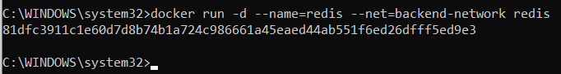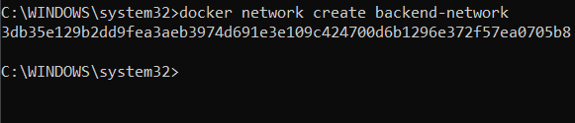

**Step 2** - Network Communication

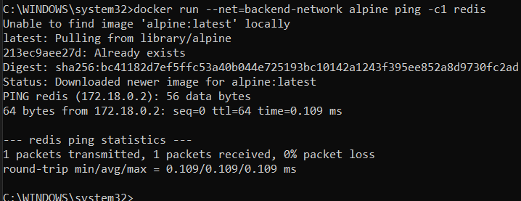

**Step 3** - Connect Two Containers

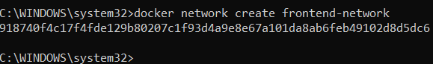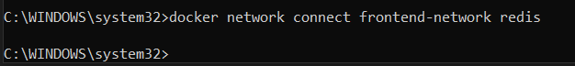

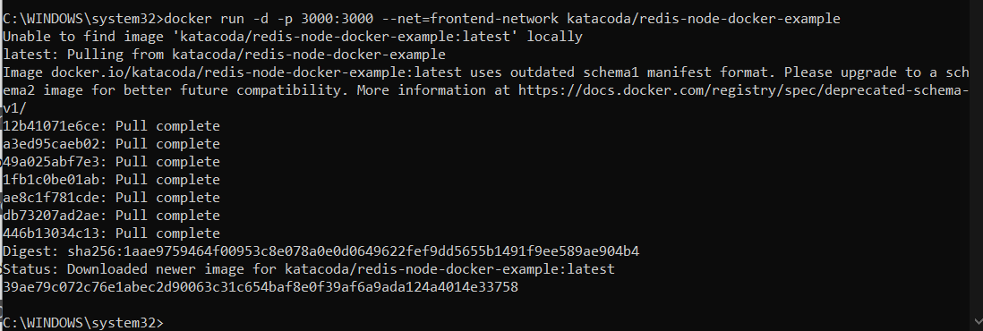

**Step 4** - Create Aliases

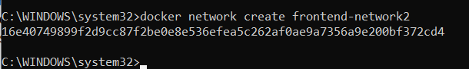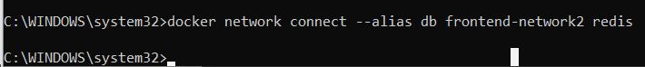

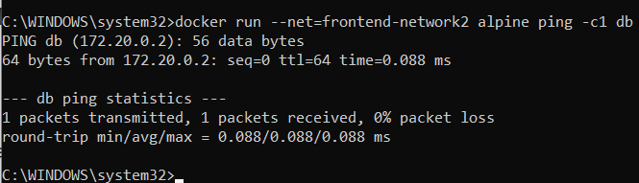

**Step 5** - Disconnect Containers

